
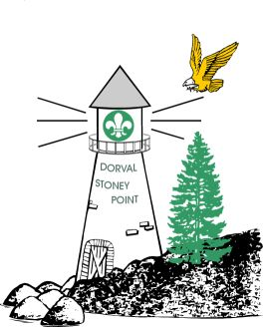

Badges
Which badge would you prefer to teach:
Please mark them as:

JUMP SCOUT
PROGRAM

CAMPING SKILLS 1-2

CAMPING SKILLS 3

TRAIL SKILLS 1-2

TRAIL SKILLS 3

EMERGENCY 1-2

EMERGENCY 3-4

PADDLING 1

PADDLING 2

Stoney Point – Dorval
Spring Cub Camp 2025
Camp Kinkora
May 30 to June 1

Application and Medical Record
(for Leaders, Cooks, Kims, guests, Scouts,Venturers,and other un-cubs)

Name: ___________________________Pack/Colony:___________________

Tel. # at home: _____________________________Male/Female:________

Circle: Leader, Cook, Kim, Scout, Venturer, Guest, 0r:_______________

.Medicare #: _______________________________ Expires: _____________

Address: _______________________________________________________

_______________________________________________________

IN CASE OF EMERGENCY PLEASE NOTIFY:

NAME: __________________________________ Tel. _______________

PLEASE LIST BELOW ANY PRESENT AILMENTS, ALLERGIES, OR HABITS WE SHOULD BE AWARE OF: (List Medications and reasons too)
ALLERGIES? Peanuts Shellfish Pork (religious)

Other (specify)_______________________________________

______________________________________________________________
If Required may we give your child Tylenol? YES NO
PARENTS’ COMMENTS :

If Required and you are under 18 may we give your child Tylenol? YES NO

Fees: $110.00 (helps pay for food)
We will be able to drive or need a lift

No T Shirt:
T Shirt size Youth : M L Men’s : S M L XL OR XXL
SIGNATURE OF Parent/Guardian/ Volunteer: _________________________________________________

Non
Cub

1
2
3

